> running<-read_csv("agree--2.csv")
Rows: 24 Columns: 3
── Column specification ────────────────────────────────────────────────
Delimiter: ","
dbl (3): runner, age, net

ℹ Use `spec()` to retrieve the full column specification for this data.
ℹ Specify the column types or set `show_col_types = FALSE` to quiet this message.
> running_model_1_prior <- stan_glmer(
+ net ~ age + (1 | runner),
+ data = running, family = gaussian,
+ prior_intercept = normal(0.43, 0.15),
+ prior = normal(-0.076, 0.025),
+ prior_aux = exponential(1, autoscale = TRUE),
+ prior_covariance = decov(reg = 1, conc = 1, shape = 1, scale = 1),
+ chains = 4, iter = 5000*2, seed = 84735,
+ prior_PD = TRUE)

SAMPLING FOR MODEL 'continuous' NOW (CHAIN 1).
Chain 1:
Chain 1: Gradient evaluation took 3.3e-05 seconds
Chain 1: 1000 transitions using 10 leapfrog steps per transition would take 0.33 seconds.
Chain 1: Adjust your expectations accordingly!
Chain 1:
Chain 1:
Chain 1: Iteration: 1 / 10000 [ 0%] (Warmup)
Chain 1: Iteration: 1000 / 10000 [ 10%] (Warmup)
Chain 1: Iteration: 2000 / 10000 [ 20%] (Warmup)
Chain 1: Iteration: 3000 / 10000 [ 30%] (Warmup)
Chain 1: Iteration: 4000 / 10000 [ 40%] (Warmup)
Chain 1: Iteration: 5000 / 10000 [ 50%] (Warmup)
Chain 1: Iteration: 5001 / 10000 [ 50%] (Sampling)
Chain 1: Iteration: 6000 / 10000 [ 60%] (Sampling)
Chain 1: Iteration: 7000 / 10000 [ 70%] (Sampling)
Chain 1: Iteration: 8000 / 10000 [ 80%] (Sampling)
Chain 1: Iteration: 9000 / 10000 [ 90%] (Sampling)
Chain 1: Iteration: 10000 / 10000 [100%] (Sampling)
Chain 1:
Chain 1: Elapsed Time: 0.379539 seconds (Warm-up)
Chain 1: 0.487313 seconds (Sampling)
Chain 1: 0.866852 seconds (Total)
Chain 1:

SAMPLING FOR MODEL 'continuous' NOW (CHAIN 2).
Chain 2:
Chain 2: Gradient evaluation took 2.7e-05 seconds
Chain 2: 1000 transitions using 10 leapfrog steps per transition would take 0.27 seconds.
Chain 2: Adjust your expectations accordingly!
Chain 2:
Chain 2:
Chain 2: Iteration: 1 / 10000 [ 0%] (Warmup)
Chain 2: Iteration: 1000 / 10000 [ 10%] (Warmup)
Chain 2: Iteration: 2000 / 10000 [ 20%] (Warmup)
Chain 2: Iteration: 3000 / 10000 [ 30%] (Warmup)
Chain 2: Iteration: 4000 / 10000 [ 40%] (Warmup)
Chain 2: Iteration: 5000 / 10000 [ 50%] (Warmup)
Chain 2: Iteration: 5001 / 10000 [ 50%] (Sampling)
Chain 2: Iteration: 6000 / 10000 [ 60%] (Sampling)
Chain 2: Iteration: 7000 / 10000 [ 70%] (Sampling)
Chain 2: Iteration: 8000 / 10000 [ 80%] (Sampling)
Chain 2: Iteration: 9000 / 10000 [ 90%] (Sampling)
Chain 2: Iteration: 10000 / 10000 [100%] (Sampling)
Chain 2:
Chain 2: Elapsed Time: 0.384311 seconds (Warm-up)
Chain 2: 0.507528 seconds (Sampling)
Chain 2: 0.891839 seconds (Total)
Chain 2:

SAMPLING FOR MODEL 'continuous' NOW (CHAIN 3).
Chain 3:
Chain 3: Gradient evaluation took 1.8e-05 seconds
Chain 3: 1000 transitions using 10 leapfrog steps per transition would take 0.18 seconds.
Chain 3: Adjust your expectations accordingly!
Chain 3:
Chain 3:
Chain 3: Iteration: 1 / 10000 [ 0%] (Warmup)
Chain 3: Iteration: 1000 / 10000 [ 10%] (Warmup)
Chain 3: Iteration: 2000 / 10000 [ 20%] (Warmup)
Chain 3: Iteration: 3000 / 10000 [ 30%] (Warmup)
Chain 3: Iteration: 4000 / 10000 [ 40%] (Warmup)
Chain 3: Iteration: 5000 / 10000 [ 50%] (Warmup)
Chain 3: Iteration: 5001 / 10000 [ 50%] (Sampling)
Chain 3: Iteration: 6000 / 10000 [ 60%] (Sampling)
Chain 3: Iteration: 7000 / 10000 [ 70%] (Sampling)
Chain 3: Iteration: 8000 / 10000 [ 80%] (Sampling)
Chain 3: Iteration: 9000 / 10000 [ 90%] (Sampling)
Chain 3: Iteration: 10000 / 10000 [100%] (Sampling)
Chain 3:
Chain 3: Elapsed Time: 0.36817 seconds (Warm-up)
Chain 3: 0.557684 seconds (Sampling)
Chain 3: 0.925854 seconds (Total)
Chain 3:

SAMPLING FOR MODEL 'continuous' NOW (CHAIN 4).
Chain 4:
Chain 4: Gradient evaluation took 1.7e-05 seconds
Chain 4: 1000 transitions using 10 leapfrog steps per transition would take 0.17 seconds.
Chain 4: Adjust your expectations accordingly!
Chain 4:
Chain 4:
Chain 4: Iteration: 1 / 10000 [ 0%] (Warmup)
Chain 4: Iteration: 1000 / 10000 [ 10%] (Warmup)
Chain 4: Iteration: 2000 / 10000 [ 20%] (Warmup)
Chain 4: Iteration: 3000 / 10000 [ 30%] (Warmup)
Chain 4: Iteration: 4000 / 10000 [ 40%] (Warmup)
Chain 4: Iteration: 5000 / 10000 [ 50%] (Warmup)
Chain 4: Iteration: 5001 / 10000 [ 50%] (Sampling)
Chain 4: Iteration: 6000 / 10000 [ 60%] (Sampling)
Chain 4: Iteration: 7000 / 10000 [ 70%] (Sampling)
Chain 4: Iteration: 8000 / 10000 [ 80%] (Sampling)
Chain 4: Iteration: 9000 / 10000 [ 90%] (Sampling)
Chain 4: Iteration: 10000 / 10000 [100%] (Sampling)
Chain 4:
Chain 4: Elapsed Time: 0.388351 seconds (Warm-up)
Chain 4: 0.479903 seconds (Sampling)
Chain 4: 0.868254 seconds (Total)
Chain 4:
> set.seed(84735)
> running %>%
+ add_fitted_draws(running_model_1_prior, n = 4) %>%
+ ggplot(aes(x = age, y = net)) +
+ geom_line(aes(y = .value, group = paste(runner, .draw))) +
+ facet_wrap(~ .draw)
Warning message:
`fitted_draws` and `add_fitted_draws` are deprecated as their names were confusing.
- Use [add_]epred_draws() to get the expectation of the posterior predictive.
- Use [add_]linpred_draws() to get the distribution of the linear predictor.
- For example, you used [add_]fitted_draws(..., scale = "response"), which
means you most likely want [add_]epred_draws(...).
NOTE: When updating to the new functions, note that the `model` parameter is now
named `object` and the `n` parameter is now named `ndraws`.

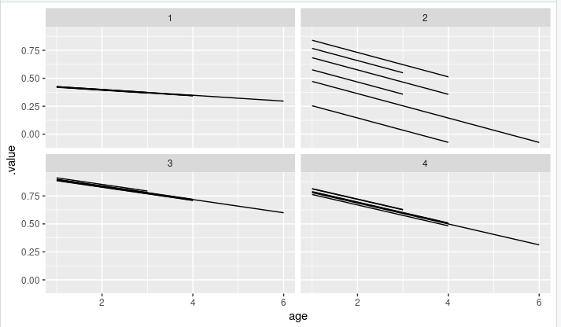

> running %>%
+ add_predicted_draws(running_model_1_prior, n = 100) %>%
+ ggplot(aes(x = net)) +
+ geom_density(aes(x = .prediction, group = .draw)) +
+ xlim(-100,300)
Warning message:

In add_predicted_draws(): The `n` argument is a deprecated alias for `ndraws`.
Use the `ndraws` argument instead.
See help("tidybayes-deprecated").

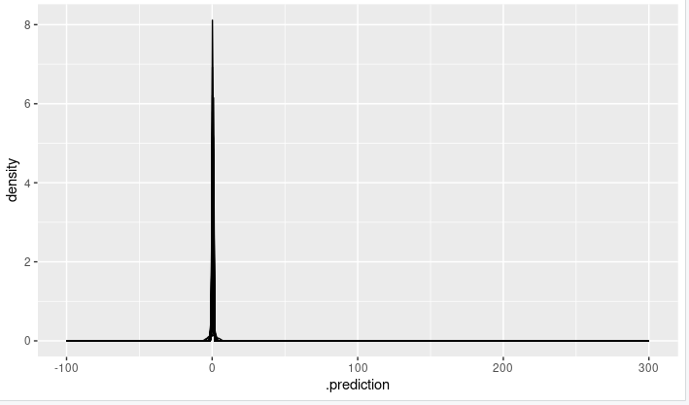

> ggplot(running, aes(x = age, y = net)) +
+ geom_point() +
+ facet_wrap(~ runner)
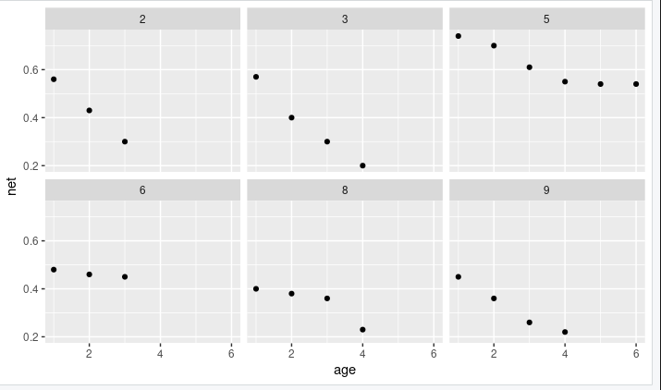

> # Simulate the posterior
> running_model_1 <- update(running_model_1_prior, prior_PD = FALSE)

SAMPLING FOR MODEL 'continuous' NOW (CHAIN 1).
Chain 1:
Chain 1: Gradient evaluation took 5.4e-05 seconds
Chain 1: 1000 transitions using 10 leapfrog steps per transition would take 0.54 seconds.
Chain 1: Adjust your expectations accordingly!
Chain 1:
Chain 1:
Chain 1: Iteration: 1 / 10000 [ 0%] (Warmup)
Chain 1: Iteration: 1000 / 10000 [ 10%] (Warmup)
Chain 1: Iteration: 2000 / 10000 [ 20%] (Warmup)
Chain 1: Iteration: 3000 / 10000 [ 30%] (Warmup)
Chain 1: Iteration: 4000 / 10000 [ 40%] (Warmup)
Chain 1: Iteration: 5000 / 10000 [ 50%] (Warmup)
Chain 1: Iteration: 5001 / 10000 [ 50%] (Sampling)
Chain 1: Iteration: 6000 / 10000 [ 60%] (Sampling)
Chain 1: Iteration: 7000 / 10000 [ 70%] (Sampling)
Chain 1: Iteration: 8000 / 10000 [ 80%] (Sampling)
Chain 1: Iteration: 9000 / 10000 [ 90%] (Sampling)
Chain 1: Iteration: 10000 / 10000 [100%] (Sampling)
Chain 1:
Chain 1: Elapsed Time: 1.78706 seconds (Warm-up)
Chain 1: 1.86956 seconds (Sampling)
Chain 1: 3.65663 seconds (Total)
Chain 1:

SAMPLING FOR MODEL 'continuous' NOW (CHAIN 2).
Chain 2:
Chain 2: Gradient evaluation took 2.8e-05 seconds
Chain 2: 1000 transitions using 10 leapfrog steps per transition would take 0.28 seconds.
Chain 2: Adjust your expectations accordingly!
Chain 2:
Chain 2:
Chain 2: Iteration: 1 / 10000 [ 0%] (Warmup)
Chain 2: Iteration: 1000 / 10000 [ 10%] (Warmup)
Chain 2: Iteration: 2000 / 10000 [ 20%] (Warmup)
Chain 2: Iteration: 3000 / 10000 [ 30%] (Warmup)
Chain 2: Iteration: 4000 / 10000 [ 40%] (Warmup)
Chain 2: Iteration: 5000 / 10000 [ 50%] (Warmup)
Chain 2: Iteration: 5001 / 10000 [ 50%] (Sampling)
Chain 2: Iteration: 6000 / 10000 [ 60%] (Sampling)
Chain 2: Iteration: 7000 / 10000 [ 70%] (Sampling)
Chain 2: Iteration: 8000 / 10000 [ 80%] (Sampling)
Chain 2: Iteration: 9000 / 10000 [ 90%] (Sampling)
Chain 2: Iteration: 10000 / 10000 [100%] (Sampling)
Chain 2:
Chain 2: Elapsed Time: 1.68851 seconds (Warm-up)
Chain 2: 1.57475 seconds (Sampling)
Chain 2: 3.26325 seconds (Total)
Chain 2:

SAMPLING FOR MODEL 'continuous' NOW (CHAIN 3).
Chain 3:
Chain 3: Gradient evaluation took 2.8e-05 seconds
Chain 3: 1000 transitions using 10 leapfrog steps per transition would take 0.28 seconds.
Chain 3: Adjust your expectations accordingly!
Chain 3:
Chain 3:
Chain 3: Iteration: 1 / 10000 [ 0%] (Warmup)
Chain 3: Iteration: 1000 / 10000 [ 10%] (Warmup)
Chain 3: Iteration: 2000 / 10000 [ 20%] (Warmup)
Chain 3: Iteration: 3000 / 10000 [ 30%] (Warmup)
Chain 3: Iteration: 4000 / 10000 [ 40%] (Warmup)
Chain 3: Iteration: 5000 / 10000 [ 50%] (Warmup)
Chain 3: Iteration: 5001 / 10000 [ 50%] (Sampling)
Chain 3: Iteration: 6000 / 10000 [ 60%] (Sampling)
Chain 3: Iteration: 7000 / 10000 [ 70%] (Sampling)
Chain 3: Iteration: 8000 / 10000 [ 80%] (Sampling)
Chain 3: Iteration: 9000 / 10000 [ 90%] (Sampling)
Chain 3: Iteration: 10000 / 10000 [100%] (Sampling)
Chain 3:
Chain 3: Elapsed Time: 1.76269 seconds (Warm-up)
Chain 3: 1.48831 seconds (Sampling)
Chain 3: 3.251 seconds (Total)
Chain 3:

SAMPLING FOR MODEL 'continuous' NOW (CHAIN 4).
Chain 4:
Chain 4: Gradient evaluation took 2.6e-05 seconds
Chain 4: 1000 transitions using 10 leapfrog steps per transition would take 0.26 seconds.
Chain 4: Adjust your expectations accordingly!
Chain 4:
Chain 4:
Chain 4: Iteration: 1 / 10000 [ 0%] (Warmup)
Chain 4: Iteration: 1000 / 10000 [ 10%] (Warmup)
Chain 4: Iteration: 2000 / 10000 [ 20%] (Warmup)
Chain 4: Iteration: 3000 / 10000 [ 30%] (Warmup)
Chain 4: Iteration: 4000 / 10000 [ 40%] (Warmup)
Chain 4: Iteration: 5000 / 10000 [ 50%] (Warmup)
Chain 4: Iteration: 5001 / 10000 [ 50%] (Sampling)
Chain 4: Iteration: 6000 / 10000 [ 60%] (Sampling)
Chain 4: Iteration: 7000 / 10000 [ 70%] (Sampling)
Chain 4: Iteration: 8000 / 10000 [ 80%] (Sampling)
Chain 4: Iteration: 9000 / 10000 [ 90%] (Sampling)
Chain 4: Iteration: 10000 / 10000 [100%] (Sampling)
Chain 4:
Chain 4: Elapsed Time: 1.70996 seconds (Warm-up)
Chain 4: 1.62467 seconds (Sampling)
Chain 4: 3.33463 seconds (Total)
Chain 4:
> # Check the prior specifications
> prior_summary(running_model_1)
Priors for model 'running_model_1'
------
Intercept (after predictors centered)
~ normal(location = 0.43, scale = 0.15)

Coefficients
~ normal(location = -0.076, scale = 0.025)

Auxiliary (sigma)
Specified prior:
~ exponential(rate = 1)
Adjusted prior:
~ exponential(rate = 6.8)

Covariance
~ decov(reg. = 1, conc. = 1, shape = 1, scale = 1)
------
See help('prior_summary.stanreg') for more details
> # Markov chain diagnostics
> mcmc_trace(running_model_1)

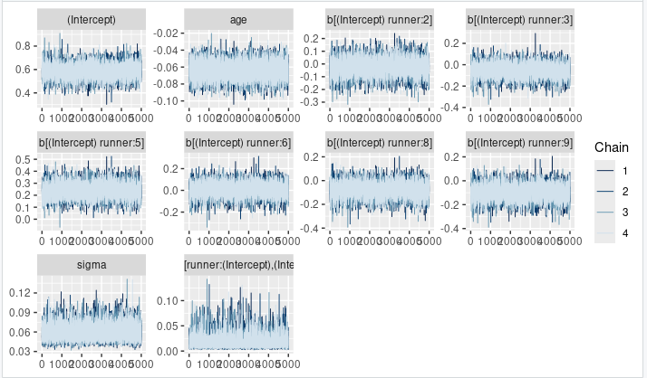

> mcmc_dens_overlay(running_model_1)

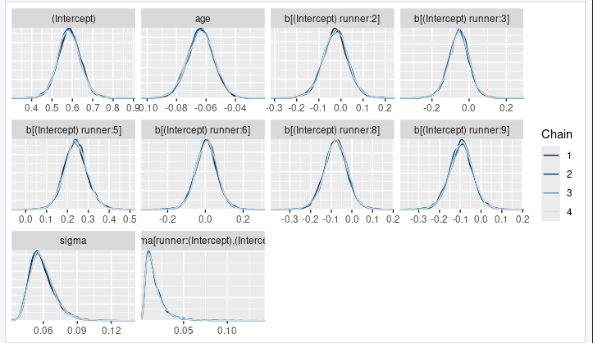

> neff_ratio(running_model_1)
(Intercept)
0.27150
age
0.77940
b[(Intercept) runner:2]
0.28425
b[(Intercept) runner:3]
0.27780
b[(Intercept) runner:5]
0.27850
b[(Intercept) runner:6]
0.29560
b[(Intercept) runner:8]
0.28425
b[(Intercept) runner:9]
0.28670
sigma
0.51120
Sigma[runner:(Intercept),(Intercept)]
0.42625
> rhat(running_model_1)
(Intercept)
1.0004696
age
0.9999535
b[(Intercept) runner:2]
1.0003947
b[(Intercept) runner:3]
1.0004592
b[(Intercept) runner:5]
1.0003436
b[(Intercept) runner:6]
1.0004415
b[(Intercept) runner:8]
1.0003863
b[(Intercept) runner:9]
1.0005523
sigma
1.0001205
Sigma[runner:(Intercept),(Intercept)]
1.0001227
> tidy_summary_1 <- tidy(running_model_1, effects = "fixed",
+ conf.int = TRUE, conf.level = 0.80)
> tidy_summary_1
# A tibble: 2 × 5
term estimate std.error conf.low conf.high
<chr> <dbl> <dbl> <dbl> <dbl>
1 (Intercept) 0.584 0.0537 0.516 0.655
2 age -0.0635 0.00889 -0.0752 -0.0519
>
> B0 <- tidy_summary_1$estimate[1]
> B1 <- tidy_summary_1$estimate[2]
> running %>%
+ add_fitted_draws(running_model_1, n = 200, re_formula = NA) %>%
+ ggplot(aes(x = age, y = net)) +
+ geom_line(aes(y = .value, group = .draw), alpha = 0.1) +
+ geom_abline(intercept = B0, slope = B1, color = "blue") +
+ lims(y = c(75, 110))
Warning messages:
1: `fitted_draws` and `add_fitted_draws` are deprecated as their names were confusing.
- Use [add_]epred_draws() to get the expectation of the posterior predictive.
- Use [add_]linpred_draws() to get the distribution of the linear predictor.
- For example, you used [add_]fitted_draws(..., scale = "response"), which
means you most likely want [add_]epred_draws(...).
NOTE: When updating to the new functions, note that the `model` parameter is now
named `object` and the `n` parameter is now named `ndraws`.
2: Removed 4800 rows containing missing values or values outside the scale
range (`geom_line()`).
> # Posterior summaries of runner-specific intercepts
> runner_summaries_1 <- running_model_1 %>%
+ spread_draws(`(Intercept)`, b[,runner]) %>%
+ mutate(runner_intercept = `(Intercept)` + b) %>%
+ select(-`(Intercept)`, -b) %>%
+ median_qi(.width = 0.80) %>%
+ select(runner, runner_intercept, .lower, .upper)
> runner_summaries_1 %>%
+ filter(runner %in% c("runner:4", "runner:5"))
# A tibble: 1 × 4
runner runner_intercept .lower .upper
<chr> <dbl> <dbl> <dbl>
1 runner:5 0.826 0.773 0.876
> # 100 posterior plausible models for runners 4 & 5
> running %>%
+ filter(runner %in% c("4", "5")) %>%
+ add_fitted_draws(running_model_1, n = 100) %>%
+ ggplot(aes(x = age, y = net)) +
+ geom_line(
+ aes(y = .value, group = paste(runner, .draw), color = runner),
+ alpha = 0.1) +
+ geom_point(aes(color = runner))
Warning message:
`fitted_draws` and `add_fitted_draws` are deprecated as their names were confusing.
- Use [add_]epred_draws() to get the expectation of the posterior predictive.
- Use [add_]linpred_draws() to get the distribution of the linear predictor.
- For example, you used [add_]fitted_draws(..., scale = "response"), which
means you most likely want [add_]epred_draws(...).
NOTE: When updating to the new functions, note that the `model` parameter is now
named `object` and the `n` parameter is now named `ndraws`.
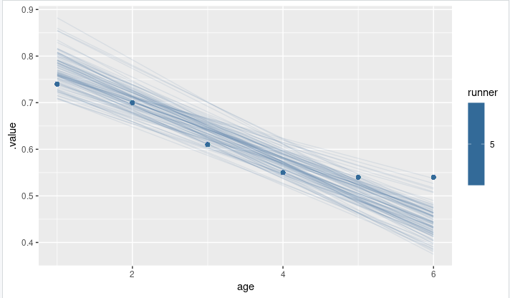

> # Plot runner-specific models with the global model
> ggplot(running, aes(y = net, x = age, group = runner)) +
+ geom_abline(data = runner_summaries_1, color = "gray",
+ aes(intercept = runner_intercept, slope = B1)) +
+ geom_abline(intercept = B0, slope = B1, color = "blue") +
+ lims(x = c(1, 6), y = c(0, 0.8))

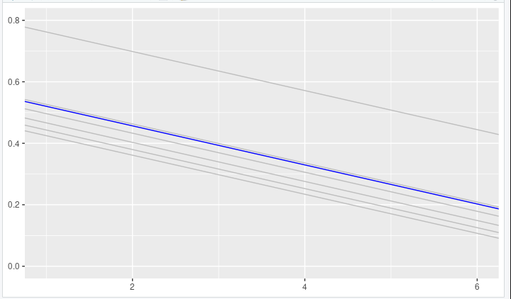

> tidy_sigma <- tidy(running_model_1, effects = "ran_pars")
> tidy_sigma
# A tibble: 2 × 3
term group estimate
<chr> <chr> <dbl>
1 sd_(Intercept).runner runner 0.132
2 sd_Observation.Residual Residual 0.0592
>
>
> sigma_0 <- tidy_sigma[1,3]
> sigma_y <- tidy_sigma[2,3]
> sigma_0^2 / (sigma_0^2 + sigma_y^2)
estimate
1 0.8328285
>
> sigma_y^2 / (sigma_0^2 + sigma_y^2)
estimate
1 0.1671715
> # Plot runner-specific models in the data
> running %>%
+ filter(runner %in% c("4", "5", "20", "29")) %>%
+ ggplot(., aes(x = age, y = net)) +
+ geom_point() +
+ geom_smooth(method = "lm", se = FALSE) +
+ facet_grid(~ runner)
`geom_smooth()` using formula = 'y ~ x'

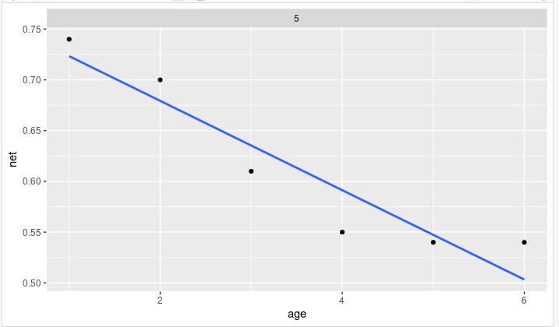

> ggplot(running, aes(x = age, y = net, group = runner)) +
+ geom_smooth(method = "lm", se = FALSE, size = 0.5)
`geom_smooth()` using formula = 'y ~ x'

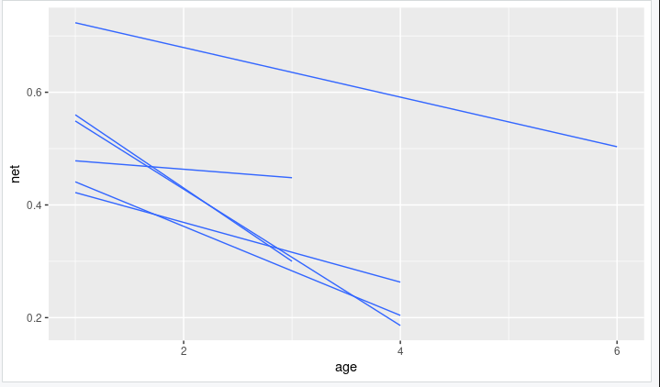

> running_model_2 <- stan_glmer(
+ net ~ age + (age | runner),
+ data = running, family = gaussian,
+ prior_intercept = normal(100, 10),
+ prior = normal(2.5, 1),
+ prior_aux = exponential(1, autoscale = TRUE),
+ prior_covariance = decov(reg = 1, conc = 1, shape = 1, scale = 1),
+ chains = 4, iter = 5000*2, seed = 84735, adapt_delta = 0.99999
+ )

SAMPLING FOR MODEL 'continuous' NOW (CHAIN 1).
Chain 1:
Chain 1: Gradient evaluation took 6.4e-05 seconds
Chain 1: 1000 transitions using 10 leapfrog steps per transition would take 0.64 seconds.
Chain 1: Adjust your expectations accordingly!
Chain 1:
Chain 1:
Chain 1: Iteration: 1 / 10000 [ 0%] (Warmup)
Chain 1: Iteration: 1000 / 10000 [ 10%] (Warmup)
Chain 1: Iteration: 2000 / 10000 [ 20%] (Warmup)
Chain 1: Iteration: 3000 / 10000 [ 30%] (Warmup)
Chain 1: Iteration: 4000 / 10000 [ 40%] (Warmup)
Chain 1: Iteration: 5000 / 10000 [ 50%] (Warmup)
Chain 1: Iteration: 5001 / 10000 [ 50%] (Sampling)
Chain 1: Iteration: 6000 / 10000 [ 60%] (Sampling)
Chain 1: Iteration: 7000 / 10000 [ 70%] (Sampling)
Chain 1: Iteration: 8000 / 10000 [ 80%] (Sampling)
Chain 1: Iteration: 9000 / 10000 [ 90%] (Sampling)
Chain 1: Iteration: 10000 / 10000 [100%] (Sampling)
Chain 1:
Chain 1: Elapsed Time: 46.5049 seconds (Warm-up)
Chain 1: 57.001 seconds (Sampling)
Chain 1: 103.506 seconds (Total)
Chain 1:

SAMPLING FOR MODEL 'continuous' NOW (CHAIN 2).
Chain 2:
Chain 2: Gradient evaluation took 4.4e-05 seconds
Chain 2: 1000 transitions using 10 leapfrog steps per transition would take 0.44 seconds.
Chain 2: Adjust your expectations accordingly!
Chain 2:
Chain 2:
Chain 2: Iteration: 1 / 10000 [ 0%] (Warmup)
Chain 2: Iteration: 1000 / 10000 [ 10%] (Warmup)
Chain 2: Iteration: 2000 / 10000 [ 20%] (Warmup)
Chain 2: Iteration: 3000 / 10000 [ 30%] (Warmup)
Chain 2: Iteration: 4000 / 10000 [ 40%] (Warmup)
Chain 2: Iteration: 5000 / 10000 [ 50%] (Warmup)
Chain 2: Iteration: 5001 / 10000 [ 50%] (Sampling)
Chain 2: Iteration: 6000 / 10000 [ 60%] (Sampling)
Chain 2: Iteration: 7000 / 10000 [ 70%] (Sampling)
Chain 2: Iteration: 8000 / 10000 [ 80%] (Sampling)
Chain 2: Iteration: 9000 / 10000 [ 90%] (Sampling)
Chain 2: Iteration: 10000 / 10000 [100%] (Sampling)
Chain 2:
Chain 2: Elapsed Time: 47.2257 seconds (Warm-up)
Chain 2: 33.1592 seconds (Sampling)
Chain 2: 80.385 seconds (Total)
Chain 2:

SAMPLING FOR MODEL 'continuous' NOW (CHAIN 3).
Chain 3:
Chain 3: Gradient evaluation took 4.8e-05 seconds
Chain 3: 1000 transitions using 10 leapfrog steps per transition would take 0.48 seconds.
Chain 3: Adjust your expectations accordingly!
Chain 3:
Chain 3:
Chain 3: Iteration: 1 / 10000 [ 0%] (Warmup)
Chain 3: Iteration: 1000 / 10000 [ 10%] (Warmup)
Chain 3: Iteration: 2000 / 10000 [ 20%] (Warmup)
Chain 3: Iteration: 3000 / 10000 [ 30%] (Warmup)
Chain 3: Iteration: 4000 / 10000 [ 40%] (Warmup)
Chain 3: Iteration: 5000 / 10000 [ 50%] (Warmup)
Chain 3: Iteration: 5001 / 10000 [ 50%] (Sampling)
Chain 3: Iteration: 6000 / 10000 [ 60%] (Sampling)
Chain 3: Iteration: 7000 / 10000 [ 70%] (Sampling)
Chain 3: Iteration: 8000 / 10000 [ 80%] (Sampling)
Chain 3: Iteration: 9000 / 10000 [ 90%] (Sampling)
Chain 3: Iteration: 10000 / 10000 [100%] (Sampling)
Chain 3:
Chain 3: Elapsed Time: 46.423 seconds (Warm-up)
Chain 3: 84.1763 seconds (Sampling)
Chain 3: 130.599 seconds (Total)
Chain 3:

SAMPLING FOR MODEL 'continuous' NOW (CHAIN 4).
Chain 4:
Chain 4: Gradient evaluation took 4.8e-05 seconds
Chain 4: 1000 transitions using 10 leapfrog steps per transition would take 0.48 seconds.
Chain 4: Adjust your expectations accordingly!
Chain 4:
Chain 4:
Chain 4: Iteration: 1 / 10000 [ 0%] (Warmup)
Chain 4: Iteration: 1000 / 10000 [ 10%] (Warmup)
Chain 4: Iteration: 2000 / 10000 [ 20%] (Warmup)
Chain 4: Iteration: 3000 / 10000 [ 30%] (Warmup)
Chain 4: Iteration: 4000 / 10000 [ 40%] (Warmup)
Chain 4: Iteration: 5000 / 10000 [ 50%] (Warmup)
Chain 4: Iteration: 5001 / 10000 [ 50%] (Sampling)
Chain 4: Iteration: 6000 / 10000 [ 60%] (Sampling)
Chain 4: Iteration: 7000 / 10000 [ 70%] (Sampling)
Chain 4: Iteration: 8000 / 10000 [ 80%] (Sampling)
Chain 4: Iteration: 9000 / 10000 [ 90%] (Sampling)
Chain 4: Iteration: 10000 / 10000 [100%] (Sampling)
Chain 4:
Chain 4: Elapsed Time: 47.9671 seconds (Warm-up)
Chain 4: 19.3614 seconds (Sampling)
Chain 4: 67.3285 seconds (Total)
Chain 4:
Warning messages:
1: There were 1 divergent transitions after warmup. See
https://mc-stan.org/misc/warnings.html#divergent-transitions-after-warmup
to find out why this is a problem and how to eliminate them.
2: Examine the pairs() plot to diagnose sampling problems

> # Confirm the prior model specifications
> prior_summary(running_model_2)
Priors for model 'running_model_2'
------
Intercept (after predictors centered)
~ normal(location = 100, scale = 10)

Coefficients
~ normal(location = 2.5, scale = 1)

Auxiliary (sigma)
Specified prior:
~ exponential(rate = 1)
Adjusted prior:
~ exponential(rate = 6.8)

Covariance
~ decov(reg. = 1, conc. = 1, shape = 1, scale = 1)
------
See help('prior_summary.stanreg') for more details
> # Quick summary of global regression parameters
> tidy(running_model_2, effects = "fixed", conf.int = TRUE, conf.level = 0.80)
# A tibble: 2 × 5
term estimate std.error conf.low conf.high
<chr> <dbl> <dbl> <dbl> <dbl>
1 (Intercept) 0.606 0.0415 0.551 0.661
2 age -0.0729 0.0188 -0.0985 -0.0469
> # Get MCMC chains for the runner-specific intercepts & slopes
> runner_chains_2 <- running_model_2 %>%
+ spread_draws(`(Intercept)`, b[term, runner], `age`) %>%
+ pivot_wider(names_from = term, names_glue = "b_{term}",
+ values_from = b) %>%
+ mutate(runner_intercept = `(Intercept)` + `b_(Intercept)`,
+ runner_age = age + b_age)
> # Posterior medians of runner-specific models
> runner_summaries_2 <- runner_chains_2 %>%
+ group_by(runner) %>%
+ summarize(runner_intercept = median(runner_intercept),
+ runner_age = median(runner_age))
> # Check it out
> head(runner_summaries_2, 3)
# A tibble: 3 × 3
runner runner_intercept runner_age
<chr> <dbl> <dbl>
1 runner:2 0.639 -0.106
2 runner:3 0.638 -0.109
3 runner:5 0.746 -0.0394
> ggplot(running, aes(y = net, x = age, group = runner)) +
+ geom_abline(data = runner_summaries_2, color = "gray",
+ aes(intercept = runner_intercept, slope = runner_age)) +
+ lims(x = c(1, 6), y = c(0, 0.8))

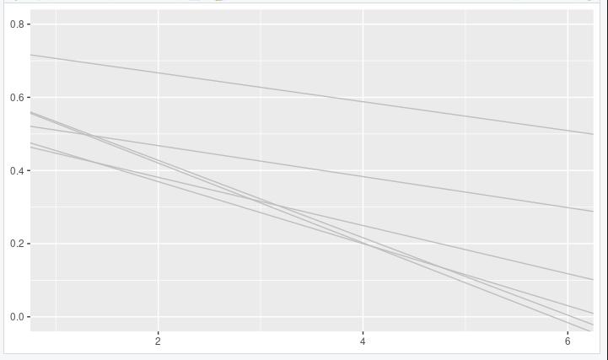

runner_summaries_2 %>%
+ filter(runner %in% c("runner:1", "runner:10"))
# A tibble: 0 × 3
# ℹ 3 variables: runner <chr>, runner_intercept <dbl>, runner_age <dbl>
> tidy(running_model_2, effects = "ran_pars")
# A tibble: 4 × 3
term group estimate
<chr> <chr> <dbl>
1 sd_(Intercept).runner runner 0.0976
2 sd_age.runner runner 0.0499
3 cor_(Intercept).age.runner runner -0.0757
4 sd_Observation.Residual Residual 0.0392
> pp_check(running_model_1) +
+ labs(x = "net", title = "running model 1")

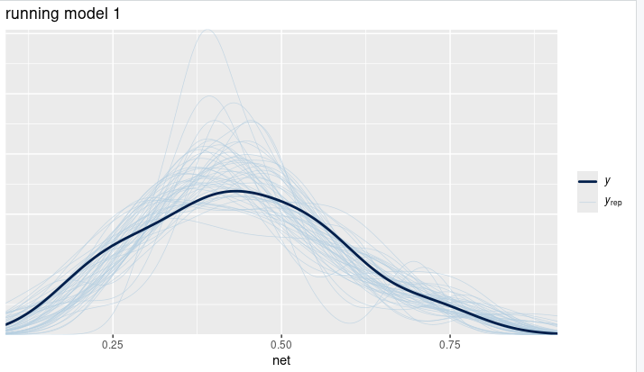

pp_check(running_model_2) +
+ labs(x = "net", title = "running model 2")

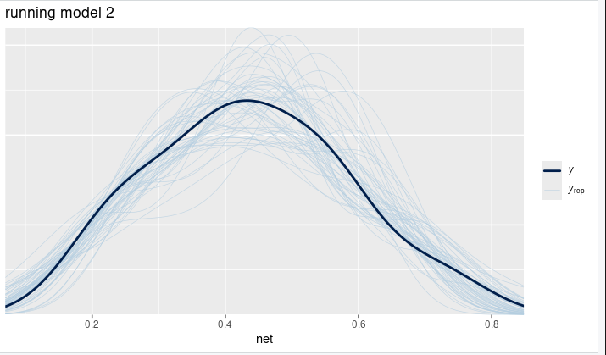

> set.seed(84735)
> prediction_summary(model = running_model_1, data = running)
mae mae_scaled within_50 within_95
1 0.02887052 0.4293451 0.6666667 1
> prediction_summary(model = running_model_2, data = running)
mae mae_scaled within_50 within_95
1 0.02100294 0.4273022 0.75 1
> #Calculate ELPD for the 2 models
> elpd_hierarchical_1 <- loo(running_model_1)
Warning message:
Found 1 observation(s) with a pareto_k > 0.7. We recommend calling 'loo' again with argument 'k_threshold = 0.7' in order to calculate the ELPD without the assumption that these observations are negligible. This will refit the model 1 times to compute the ELPDs for the problematic observations directly.

> elpd_hierarchical_2 <- loo(running_model_2)
Warning message:
Found 6 observation(s) with a pareto_k > 0.7. We recommend calling 'loo' again with argument 'k_threshold = 0.7' in order to calculate the ELPD without the assumption that these observations are negligible. This will refit the model 6 times to compute the ELPDs for the problematic observations directly.

> # Compare the ELPD
> loo_compare(elpd_hierarchical_1, elpd_hierarchical_2)
elpd_diff se_diff
running_model_2 0.0 0.0
running_model_1 -7.0 3.0
> # Plot runner-specific trends for runners 1 & 10
> running %>%
+ filter(runner %in% c("6", "8")) %>%
+ ggplot(., aes(x = age, y = net)) +
+ geom_point() +
+ facet_grid(~ runner) +
+ lims(x = c(1, 8))

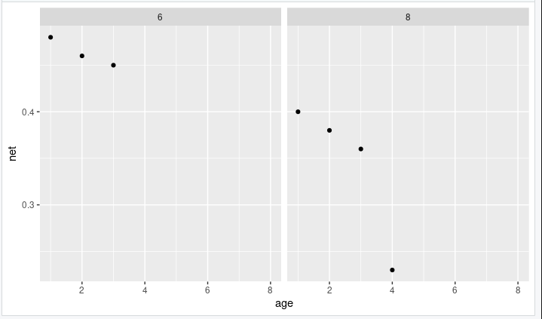

> set.seed(84735)
> predict_next_race <- posterior_predict(
+ running_model_1,
+ newdata = data.frame(runner = c("6", "P11", "8"),
+ age = c(5, 1,6)))
> B0 + B1 * 61
[1] -3.291769
>
>
>
> # Posterior predictive model plots
> mcmc_areas(predict_next_race, prob = 0.8) +
+ ggplot2::scale_y_discrete(labels = c("runner 6", "P11", "runner 8"))
Scale for y is already present.
Adding another scale for y, which will replace the existing scale.
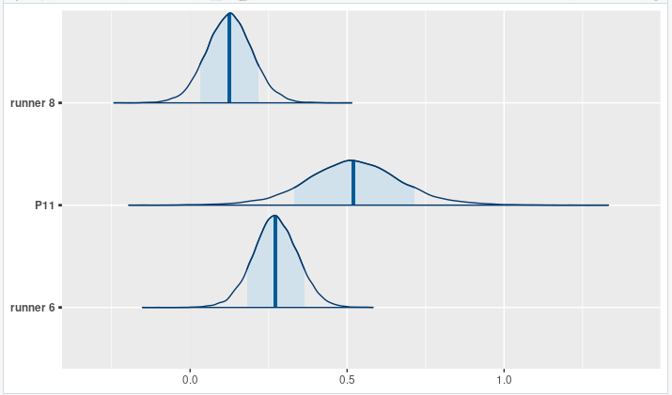
> # 计算每个选手的分位数
> quantiles <- apply(predict_next_race, 2, function(x) {
+ quantile(x, probs = c(0.25, 0.50, 0.75))
+ })
> # 将结果转换为更易读的格式
> quantiles_df <- as.data.frame(quantiles)
> colnames(quantiles_df) <- c("runner6", "P11", "runner8")
> rownames(quantiles_df) <- c("25%", "50%", "75%")
> # 显示结果
> print(quantiles_df)
runner6 P11 runner8
25% 0.2249245 0.4231340 0.07623234
50% 0.2714144 0.5200370 0.12541375
75% 0.3194959 0.6184589 0.17370195

